RECIPE  
Bistec Encebollado

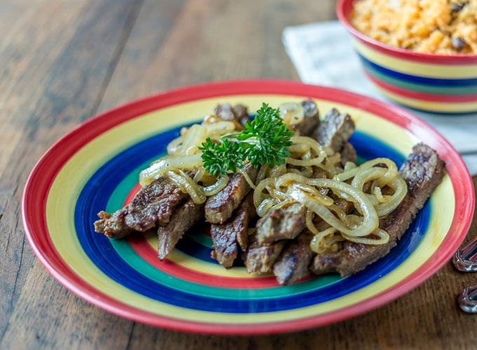

# Ingredients (marinade)

* ¼ cup Red wine vinegar/ red wine/ rice vinegar
* 2 tbsp olive oil
* 2 tsp sea salt
* 2 tsp oregano
* 1 tbsp cumin
* 2 cloves garlic, minced

# Ingredients (other)

* 2 lb beef chuck roast or flank, sliced thin
* 2 tbsp olive oil
* 2 onions, thinly sliced
* ½ cup chicken stock

# Preparation

1. Mix the ingredients together for the marinade into a large ziplock bag.
2. Add in the meat and make sure it is all coated, leave to marinate for 8-10 hours, checking every once and a while and moving it around
3. Heat olive oil in a skillet and saute the onions until just translucent, then add in the chicken stock and simmer until the liquid is gone
4. Remove the onions, add more oil to the skillet and cook the beef until done
5. Serve beef with onions on top, good with beans, rice, and salad!